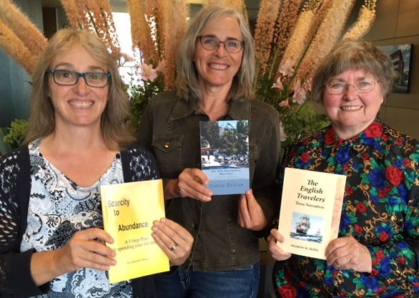  OCT. 27 2018  PUBLISH YOUR PASSION  We are not experts.  But we did it, and you can too!  Join three self-published authors (two UVic Alumnae) who write in a wide variety of genres as we relate experiences with the self-publishing process and present short readings from our books. Enjoy discussion, light refreshments and book door prizes at the event.  There is no fee to attend, but registration is required. Please RSVP at daphluck3@gmail.com with your full name and if you are a graduate of UVic. We look forward to seeing you there!  This event is supported by the UVic Alumni Association. | CELESTE DERKSEN (PhD ’99)  SHARON HOPE (BA ’66)  JENNIFER MANN  ────  University of Victoria  Fine Arts Building -Room 104  ────  Oct. 27 ,2018  1:30 - 3 pm  ────  Get your writing juices flowing  ────  Learn about self-publishing  This is a free event. Registration required.  ────  RSVP AT  daphluck3@gmail.com

